Students should arrive promptly at 2:56 for afterschool sessions, as they will begin at 3:00. Algebra 1 Saturday review sessions will start at 9:00 and end at 11:00. Please have your ride waiting.  Students should bring their own paper and pencil, so that they can be actively engaged in the session.  Misbehavior will not be tolerated. Any students who misbehave may be asked to leave and might lose the ability to attend other SOL review sessions. |  |  | 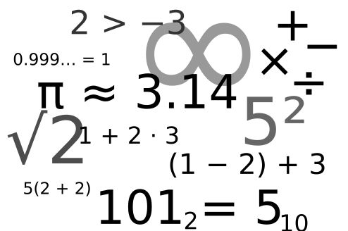  Edison Math Department  SOL Review/Remediation Plan  2018-2019  Edison High School SOL Review Schedule Math  5801 Franconia Road Alexandria Va, 22310 |  |  | Edison High School SOL Review Schedule Math

Algebra 1  SOL TEST DATE: Friday May 10, 2019  After School Sessions  All after school Algebra 1 SOL review sessions will be located in Room D122. Sessions begin promptly at 3:00 and end at 4:00 p.m.  April 29th and 30th: Expressions/Operations  May 1st and 2^{ne}: Equations/Inequalities  May 6th and 7th: Functions/Statistics  May 8th: Calculator Tools (Desmos & TI84)  May 9th: Review All Concepts  Saturday Review Sessions  Saturday Review Sessions are located in room D122 and begins promptly at 9:00 a.m. and ends at 11:00 a.m.  Saturday April 27th – SOL Practice Test  Saturday May 4th – SOL Practice Test  Saturday May 18th: Re-takers only  Algebra 1 Remediation Sessions  For students who fall into the retake range, students will attend remediation during the school day. |  |  | Geometry  SOL TEST DATE: Wednesday May 15, 2019  After School Sessions  All after school Geometry SOL review sessions will begin promptly at 3:00 and end at 4:00 p.m., in R D126.  April 25th: Tech Day Constructions  April 30th :RC1Reasoning,Lines Transformations  May 2nd RC2-Triangles  May 6th: RC3- Polygons Circles 3-D Figures  May 9th: Tech Day Constr/General Review  May 14st : VDOE Most Missed Q’s  Saturday Review Sessions  Saturday Review Sessions begin promptly at 9:00 a.m. and ends at 1:00 p.m., in R D126.  Saturday April 27th – SOL Practice Test  Saturday May 4th – SOL Practice Test  Saturday May 11th – SOL Practice Test  Geometry Remediation Sessions  For students who fall into the retake range, students will attend remediation during the school day. Subject matter will be targeted individually, based on SOL test results. |  |  | Algebra 2  SOL TEST DATE: Monday May 13, 2019  After School Sessions  All after school SOL review sessions will be located in Room D123. Sessions begin promptly at 3:00 and end at 4:00 p.m.  April 23: Expressions/Operations  April 25: Equations/Inequalities  April 30: Families of Functions/Graphing  May 2: Probability/Statistics  May 7: Calculator Tools  May 9: General Review – All Concepts  Algebra 2 Remediation Sessions  For students who fall into the retake range, students will attend remediation during the school day. Subject matter will be individually targeted based on SOL test results.

